**Toy Sales Report**

* + **1. Production Performance Analysis**

select* from Toy_product

select top 5 P.product_id, P.Product_name, sum(S.units) as 'Total_units_sold',

sum(S.units *Product_price) as revenue, Sum(S.units * (product_price-product_cost)) as 'Profit'

from Toy_product P

join Toy_sale s

on p.product_id=s.product_id

group by p.product_id,P.product_name

order by profit desc

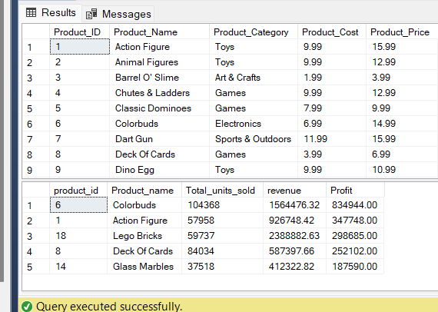

**2. Store Performance Analysis**

select s.store_id, s.Date, st.store_name, sum(s.units) as 'Total_units_sold',

sum(s.units*p.product_price) as 'total_rev',

SUM(s.units * (product_price-product_cost)) as 'profit'

from Toy_sale s

join Toy_store st

on s.store_id=st.store_id

join Toy_product p

on s.product_id=p.product_id

group by s.store_id, s.Date, st.store_name

order by profit desc

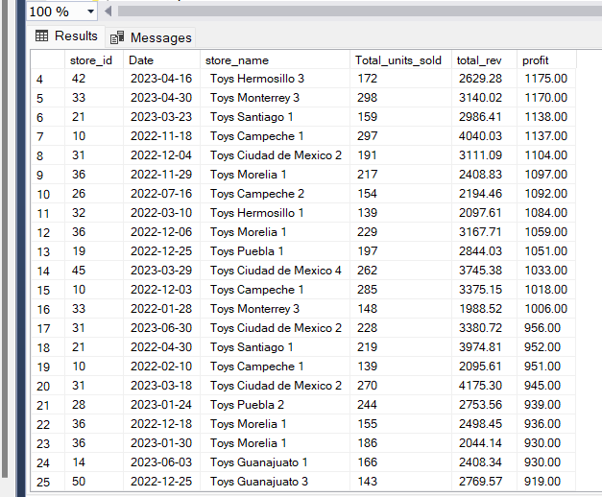

**3. Complex Monthly Sales Trend Analysis**

ith Sales_trnd As (select datename(month,date) as 'sales_month',

sum(case when year(date)=2022 then units else 0 end) as 'sales_of_2022',

sum(case when year(date)=2023 then units else 0 End) as 'Sales_of_2023',

(sum(case when year(date)=2023 then units else 0 end)-

sum(case when year(date)=2022 then units else 0 End)) as 'diff_in_sales'

from Toy_sale

group by datename(month,date))

Select *,round(cast((100.0* diff_in_sales/sales_of_2022) as float),2) as 'Perc_diff_in_sales'

, case when diff_in_sales<0 then 'Decline_in_sales'

when diff_in_sales>0 then 'growth_in_sales'

else ''

end as 'sales_trend'

from sales_trnd

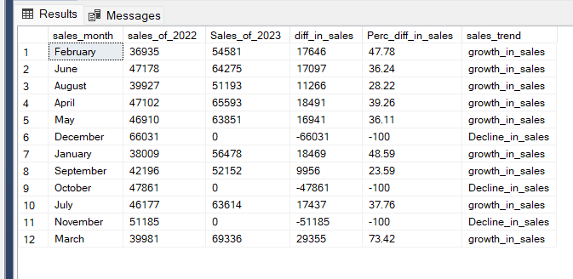

**4. Cumulative Distribution of Profit Margin**

select P.product_id, P.Product_category,

sum(S.units *Product_price) as revenue, Sum(S.units * (product_price-product_cost)) as 'Profit'

from Toy_product P

join Toy_sale s

on p.product_id=s.product_id

group by p.product_id,P.product_category

order by profit desc

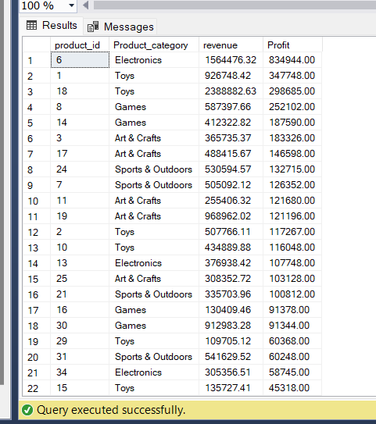

**5. Store Inventory Turnover Analysis**

with sales_category as ( select p.product_category,

SUM(case when year (s.date)=2022 then s.units*p.product_cost else 0 end) as COGS_2022

,SUM(case when year (s.date)=2022 then s.units*p.product_cost else 0 end) as COGS_2023

from Toy_sale s

join Toy_product p

on s.product_id=p.product_id

group by p.product_category)

,avg_inventory as (select p.product_category,avg(case when year(s.date)=2022 then i.stock_on_hand else 0 end) as Avg_inventory_2022

,avg(case when year(s.date)=2023 then i.stock_on_hand else 0 end) as Avg_inventory_2023

from Toy_inventory i

join Toy_product P

on i.product_id=p.product_id

join Toy_sale S

on i.product_id=s.Product_ID

group by p.Product_Category)

,Inv_goods_sold as (select sc.product_category, sc.COGS_2022, ai.Avg_inventory_2022, sc.COGS_2023,ai.Avg_inventory_2023

from sales_category sc

join avg_inventory Ai

on sc.product_category=ai.product_category)

select Product_category,COGS_2022,avg_inventory_2022,(COGS_2022/avg_inventory_2022) as inv_turn_ratio_2022,cogs_2023, avg_inventory_2023,

(COGS_2023/avg_inventory_2023) as inv_turn_ratio_2023

from Inv_goods_sold

